ST. XAVIER’S COLLEGE

**Maitighar, Kathmandu**

**(Affiliated to Tribhuvan University)**



**Computer Graphics**

**Lab Assignment #1**

**Submitted By**

Alok Shrestha

B.Sc. CSIT

Year II/IV Semester

013BSCIT005

**Submitted To**

Er. Anil Sah

Lecturer

Department of Computer Science

St. Xavier’s College

Maitighar, Kathmandu

**Submitted On**

August 4, 2015

**STATEMENT**

**DRAW THE FOLLOWING CHECKBOX.**

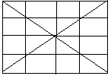

**SOURCE CODE**

//---------------------------------------------------------------------------

#include <vcl\vcl.h>

#pragma hdrstop

#include "Unit1.h"

//---------------------------------------------------------------------------

#pragma resource "*.dfm"

TForm1 *Form1;

//---------------------------------------------------------------------------

__fastcall TForm1::TForm1(TComponent* Owner)

: TForm(Owner)

{

}

//---------------------------------------------------------------------------

void __fastcall TForm1::Button1Click(TObject *Sender)

{

//border

Form1->Canvas->MoveTo(0,0);

Form1->Canvas->LineTo(200,0);

Form1->Canvas->LineTo(200,200);

Form1->Canvas->LineTo(0,200);

Form1->Canvas->LineTo(0,0);

//diagonals

Form1->Canvas->LineTo(200,200);

Form1->Canvas->MoveTo(0,200);

Form1->Canvas->LineTo(200,0);

//midlines

Form1->Canvas->MoveTo(0,100);

Form1->Canvas->LineTo(200,100);

Form1->Canvas->MoveTo(100,0);

Form1->Canvas->LineTo(100,200);

//sidelines

Form1->Canvas->MoveTo(0,50);

Form1->Canvas->LineTo(200,50);

Form1->Canvas->MoveTo(0,150);

Form1->Canvas->LineTo(200,150);

Form1->Canvas->MoveTo(50,0);

Form1->Canvas->LineTo(50,200);

Form1->Canvas->MoveTo(150,0);

Form1->Canvas->LineTo(150,200);

}

//---------------------------------------------------------------------------

**OUTPUT/s**

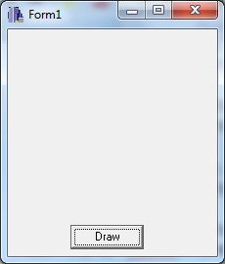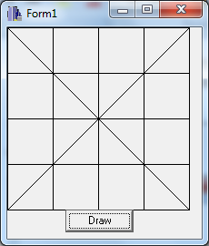

When button has not been clicked After button was clicked.

**CONCLUSION**

Hence, the given checkbox was drawn using MoveTo() and LineTo() in C++builder.